Description of Pain
Patient Name: _______________________ DOB: ____\____\______ Height: ________ Weight: ________
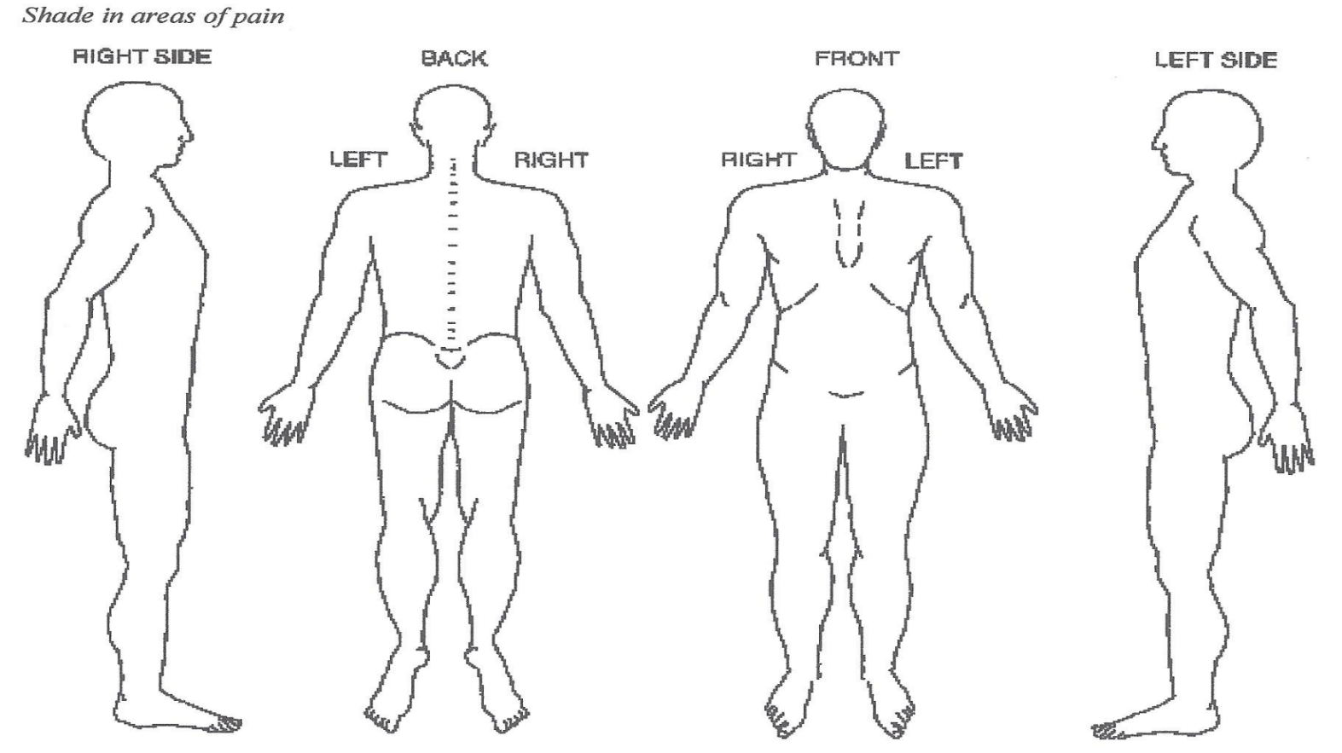

Please CIRCLE your pain score below:
0 1 2 3 4 5 6 7 8 9 10
No Pain Moderate Severe Pain
Check Words That Best Describe Your Pain
Dull Aching Sharp Shooting Stabbing Burning Radiating Pounding
Numb Tingling Cramping Electric Pulling Throbbing Tearing Unbearable
Are you experiencing any Weakness? Yes No
Are you experiencing any Loss of Bowel/Bladder Control? Yes No
Is this a Work Injury/Auto Injury? Yes No If Yes: Skip to appropriate Work/Auto Injury Box on the next page!
History of Present Illness
Date of injury of when pain began? _____/_____/______ How long has he pain been present? ______________________________
How did the injury or pain occur (Use back of page if more space is needed)? _____________________________________________
____________________________________________________________________________________________________________________________________________________________________________________________________________________________________________________________________________________________________________________________________

Patient Name _______________________________
Work Injury
What is the Date of Injury? _____/_____/______
What body part was injured? Right Left Bilateral
Abdomen Ankle Arm Calf Chest Clavicle Elbow
Face Foot Groin Hand Head Hip Knee
Leg Low Back Mid Back Neck Pelvis Shoulder Sternum
Upper Back Wrist

Causes and Circumstances of accident ___________________________________________________________________________
__________________________________________________________________________________________________________
__________________________________________________________________________________________________________
Employment status: Full Time Part Time Light Duty Other: ____________________________
Did you report your accident that day? Yes No Did you complete that day of work? Yes No
How many days of work did you miss immediately after the injury? ___________________________________________________
Has a Physician taken you off work? Yes No If yes: Dr. ___________________ Phone #: ___________________
Are you working now? Yes No If no, last day of work _____/______/______
When did you first seek medical care? _____________ With Who/Where? ____________________________________________
Any chronic/pre-existing injuries contributing to current injury? _____________________________________________________
__________________________________________________________________________________________________________
Have you had any other occurrences? Yes No If yes: Work Slip and fall Motor Vehicle Sports Injury
What injuries did you sustain as a result of other occurrences? _______________________________________________________
Did those other injuries resolve: Yes No If NO, what injuries are you still undergoing treatment for? ______________
__________________________________________________________________________________________________________

Auto Injury
What is the Date of Injury? ______/______/_______
What body part was injured? Right Left Bilateral
Abdomen Ankle Arm Calf Chest Clavicle Elbow
Face Foot Groin Hand Head Hip Knee
Leg Low Back Mid Back Neck Pelvis Shoulder Sternum
Upper Back Wrist

Location of Accident: _______________________________________________________________________________________

Where was the car hit? Struck from behind Head on Driver’s side hit Passenger side hit
Vehicle lost control
Where was the patient sitting in the car? Driver Front passenger Rear passenger
Did the car rollover? Yes No
Was the patient wearing a seatbelt? Yes No If yes, did the airbag deploy? Yes No
Did the patient loose loss of consciousness? Yes No
Damage to the vehicle? Minimal Extensive Car Totaled
Was this a pedestrian vs. Car Injury? Yes No

Did you go to the hospital? Yes

Patient Name _______________________________
Auto Injury Cont’d
Did you go to the hospital? Yes No If so, which hospital? ___________________________________________________
Were you given any pain medication? Yes No If yes, Please list: _______________________________________________
Did you seek treatment after the hospital? Yes No If yes, explain: _________________________________________________
__________________________________________________________________________________________________________

History of Present Illness (Cont’d)
Has your pain affected your daily activities or relationships with family or friends? Yes No If yes, explain: ________________
____________________________________________________________________________________________________________
Frequency of your pain: Constant Intermittent
Is there anything that worsens the pain? (Mark below)
Bending Coughing Daily Activities House Work Prolonged
Stairs Twisting Kneeling Lifting Lying Down
Nothing Neck Movement Prolonged Positions Sitting Standing
Stretching Coughing/Sneezing Getting Dressed Walking Weather Changes
Other, Explain: ______________________________________________________________________________________________

Is there anything that makes the pain better? (Mark below)
Rest Bending Forward Bending Backward Twisting Massage Ice Heat
Walking Stretching Muscle Relaxant NSAIDS’s Lying Down Medications Narcotics Switching Position
Does your pain radiate? Yes No
If yes: Right Arm Left Arm Right Leg Left Leg Buttocks Shoulder Blades
Orbit Other: _________________________________________________________________
Have you missed work due to your condition? ______________________________________________________________________
Are you currently on work restriction? ____________________________________________________________________________
Are you, or could you possibly be pregnant? Yes No
Treatments (eg: Physical Therapy/Chiropractic/Occupational Therapy/Massage)
 |  | Type of Therapy
 | Physical Therapy | Chiropractic | Occupational Therapy | Massage
Most recent visit
Treatment provided by:
Length of treatment
Duration of relief
(eg: temporary/long lasting...)
Home Exercise Program? (Please Circle) Yes No If so, when did you start? _________________________________________
Type of Exercise Duration (minutes) Frequency (times per week)

Patient Name ______________________________
Previous Injection Therapy
Type of Injection | Injection Date/How long ago | Did injection help | Length of relief
Tests performed to evaluate the problem: (circle all that apply)
X-Ray MRI CT Bone Scan EMG Other None
Test Area Tested Date Tested Facility
____________________________________________________________________________________________________________________________________________________________________________________________________________________________________________________________________________________________________________________________________
Review of Systems
General (Constitutional) Eyes Ears
Chills Yes No Blurred Vision Yes No Loss of Hearing Yes No
Fatigue Yes No Eye Pain Yes No Ringing Yes No
Fever Yes No Eye Drainage Yes No
Night Sweats Yes No Gastrointestinal
Weight Change Yes No Respiratory Nausea Yes No
Cough Yes No Vomiting Yes No
Cardiovascular Wheezing Yes No Diarrhea Yes No
Chest Pain Yes No Short of breathe Yes No Constipation Yes No
Dizziness Yes No
Palpitations Yes No Musculoskeletal Skin (Integumentary)
Back Pain Yes No Rash Yes No
Genitourinary System Joint Stiffness Yes No Atypical Mole Yes No
Abdominal Pain Yes No Limb Pain Yes No Change in Nails Yes No
Bloating Yes No
Pain w/urination Yes No Psychiatric Endocrine
Anxiety Yes No Enlarged Yes No
Neurologic Depression Yes No Hands/Feet Yes No
Dizziness Yes No Mood Change Yes No Hot/Cold Yes No
Headache Yes No Intolerance Yes No
Seizures Yes No Hair Loss Yes No

Medical History (Check all that apply)
AIDS/HIV Aneurysm Osteoarthritis Rheumatoid Arthritis Osteoporosis Asthma
Blood Clots Cancer COPD Heart Attack Depression Diabetes
Fibromyalgia Heart Disease Hepatitis Hypercholesterolemia Other (please describe below)
________________________________________________________________________________________________________________________________________________________________________________________________________________________
Surgical History
Date Operation Surgeon Facility
____________________________________________________________________________________________________________________________________________________________________________________________________________________________________________________________________________________________________________________________________

Patient Name ______________________________
Family History
Relationship to Patient (mother, father, etc.) Medical Problem
____________________________________________________________________________________________________________________________________________________________________________________________________________________________________________________________________________________________________________________________________________________________________________________________________________________________________________________________________________________________________________________________________________________________
Social History
Marital Status: Married Single Divorced Widowed Separated
Do you use tobacco? Yes No
Have you ever smoked? Yes No If yes, how many years have/did you smoke(d)? ________________
How many cigarettes per day? _______ Cigars per day? __________ Pipe? ____________
Do you drink alcohol? Yes No Former
Alcohol Frequency: Daily Weekly Monthly Rare Socially Never
Do you have a history of alcohol abuse? Yes No
Do you drink caffeinated beverages? Yes No
If yes, what is the frequency of use? Daily Weekly Monthly Rare Socially Never
Are you on a specialized/FAD diet? Yes No If yes, please describe: ______________________________________
Do you use recreational drugs? Yes No Former
Do you have a history of drug abuse? Yes No
Have you ever used any street drugs? Yes No
What drugs have you used? ____________________________________________ When did you last use it? ___________________
How often? _______________________________________________________
Hobbies: List your hobbies: Fishing Golf Hunting Sports Gardening Sewing Reading
Others _____________________________________________________________________________________________________
Are you participating in these activities now? Yes No If yes, how often? ___________________________________
Psychiatric History
Have you ever been treated for emotional/behavioral disorders? Yes No
If yes, when? _________________________________________________________________
Do you currently have ACTIVE suicidal thoughts? Yes No
Do you have a history of suicidal attempts? Yes No
Name of Psychiatrist: __________________________________________________________________________________________

Patient Name ______________________________
Allergies
Penicillin Sulfa Tetracycline Radiographic Dyes Topical Iodine Shellfish Latex
Foods Other: _______________________________________________________________________________
Do you take any blood thinners? Yes No If yes, choose which one(s) below:
Coumadin/Warfarin Pletal(Cilostazol) Plavix(Clopidrogel) Aspirin Aggenox Pradaxa
Brilinta Dipyridamole Ticagrelor Ticlid Trental Persantine
Others: ____________________________________________________________________________________________________
Supplements (Circle your response)
Herbal Medication Yes No
Dietary Yes No
Vitamins Yes No
Other (list) ________________________________________________________________________
Current Medications (please provide list if possible)
Medication Dose Frequency
________________________________________________________________________________________________________________________________________________________________________________________________________________________________________________________________________________________________________________________________________________________________________________________________________________________________________________________________________________________________________________________________________________________________________________________________________________________________________________________________________________________________________________________________________________________________________________________________________________________________________________________________________________________________________________________________________________________________________________________________________________________________________________________________________________________________________________________________________________________________________________________________________________________________________________________________________________________________________________________________________________________________________________________________________________________________________________________________________________________________________________________________________________________________________________________________________________________________________________________________________________________________________________________________________________________________________________________________
My signature confirms that the answers to the above questions are accurate and stated to the best of my ability.
Parent or Guardian Signature (if under 18): ______________________________________________________Date:______________
Patient Signature: __________________________________________________________________________Date: ______________
Physicians Signature: _______________________________________________________________________Date: ______________

